Automatic break failure indicator and engine over heating alarm

Abstract:

The braking system of a car is undoubtedly one of its more important features. The aim of this work is to create a better braking system with indicator. Brake failure occurs only because of worn out of brake shoe and cut in liner. It consists of two sensors. One sensor is connected with the brake shoe. The other sensor is the brake liner. The signal from the two sensors is given to a microcontroller. When the brake shoe is worn out, the sensor senses signal to the microcontroller. Also if the brake liner is cut, the sensor sends signal to the microcontroller. The microcontroller analyses the signal and operates the corresponding indicator. It nothing wrong, the vehicle will move and if any one critical, the vehicle will stops and the screen shows the indication of brake failure. Since this indicates the status of the brake, the user can identify the condition of the brake and thus limiting the chances of malfunction.Car safety is the avoidance of automobile accidents or the minimization of harmful effects of accidents, in particular as pertaining to human life and health. Special safety features have been built into cars for years, some for the safety of car’s occupants only, and some for the safety of others.Automatic brake failure indicator and engine over heating alarm is consists of IR sensor circuit, Heat sensor Circuit, Control Unit and frame. The sensor is used to detect the brake wire. There is any disconnection of the brake wire or cutting of any few turns of brake wire, the control signal to the alarm unit. Similarly the heat sensor is fixed to the engine and this heat is measured and giving the alarm signal when the engine heat exceeds the setted temperature limit.

Aim:

The aim is to design and develop a control system based an electronically controlled automatic brake failure indicator by using IR Sensor and engine over heating alarm by using heat sensor is called “AUTOMATIC BRAKE FAILURE INDICATOR AND ENGINE OVER HEATING ALARM”.

Existing theory:
Though the world is getting modernized, we have to face so many problems. One of such problems is accidents. One of the thing that everyone tried to avoid is while traveling is accidents, and sometimes it is inevitable. Now- a-days we can see accidents in every nook and corner of the world. It results in the death of thousands of lives. In foreign countries they take remedial measures for the prevention of accidents but our country like India takes less action against the prevention of accidents. When the driver brakes they are actually pushing a plunger into the master cylinder, which in turn pushes brake fluid through tubes and hoses to brake all the moving units in the vehicle. So many other devices are there to predict brake Research Article Volume 6 Issue No. 7 International Journal of Engineering Science and Computing, July 2016 8672 http://ijesc.org/ failure like United States patent 3711827, United States patent 3914734, etc. The United States patent 3711827 is a self-test incorporated to determine if the warning light is operated properly. But my project can indicate brake failure and the function of the brake whenever the brake is applied and it is less expensive compared to other products.

Proposing Theory:

project “automatic head light dim/bright controller and engine over heat alarm” which is fully equipped by sensors circuit, dim/bright light and engine over heat alarm circuit. It is genuine project which is fully equipped and designed for automobile vehicles. This forms an integral part of best quality.The braking system of a car is undoubtedly one of its more important feature. The aim of this work is to create a better braking system with indicator. Brake failure occurs only because of worn out of brake shoe and cut in liner. It consists of two sensors. One sensor is connected with the brake shoe. The other sensor is the brake liner. The signal from the two sensors is given to a microcontroller. When the brake shoe is worn out, the sensor senses signal to the microcontroller. Also if the brake liner is cut, the sensor sends signal to the microcontroller. The microcontroller analyses the signal and operates the corresponding indicator. It nothing wrong, green indicator will glow and if any one critical, red indicator will glow. If the brake is failure in running time, an alternate brake will be operated by the microcontroller automatically. This prevents unnecessary accident. Since this indicates the status of the brake, the user can identify the condition of the brake and thus limiting the chances of malfunction

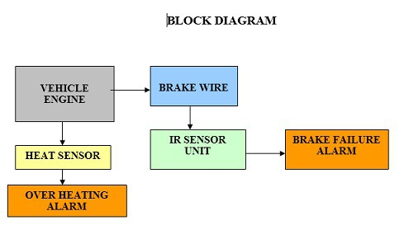

ADVANTAGES

- Low cost automation project.
- Less power consumption
- Operating Principle is very easy.
- Installation is simplified very much.
- Less time and more profit.

APPLICATIONS

- Four wheeler application
- Two Wheeler Application

DISADVANTAGES

1. This circuit is not working on low rain fall.
2. This system applied in the case of water falling on the class period only.
3. Addition cost is required to install this system to four wheeler

